L05b-W6-DBS301-non-simple joins

**Name : Avinash Singh**

**Course : DBS301**

**Proffessor : Ayesha manzer**

**Lab 5A**

**Date : 6-Oct-2017.**

1. Display the department name, city, street address and postal contry name for all Departments. Use the JOIN and USING form of syntax.

Sort the output by department name descending.

**SELECT d.department_name AS "Department Name",**

**L.city AS "City",**

**L.street_address AS "Street Address",**

**L.postal_code AS "Postal Code",**

**c.country_name AS "Country"**

**FROM departments D**

**JOIN locations L**

**USING(location_id)**

**LEFT JOIN countries C**

**USING(country_id)**

**ORDER BY department_name DESC;**

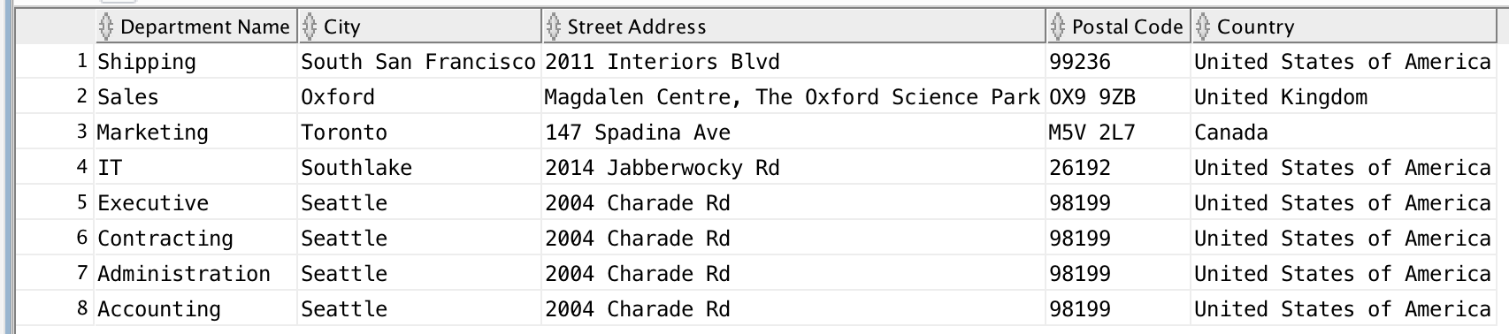

2. Display full name of the employees, their hire date and salary together with their department name, but only for departments which names start with **A** or **S**. Full name should be in format of :

**First / Last.** Use the JOIN and ON form of syntax.

Sort the output by department name and then by last name.

**SELECT E.first_name || ' ' || E.last_name AS "Full Name",**

**E.hire_date AS "Hire Date",**

**E.salary AS "Salary",**

**D.department_name AS "Department"**

**FROM employees E**

**LEFT JOIN departments D**

**ON D.department_id = E.department_id**

**WHERE D.department_name LIKE 'A%'**

**OR D.department_name LIKE 'S%'**

**ORDER BY D.department_name, e.last_name;**



3. Rewrite the previous question by using Standard (Old -- prior to Oracle9i) Join

method.

**SELECT first_name||'/'|| last_name AS "Full Name" ,**

**hire_date,**

**salary,**

**department_name**

**FROM employees**

**JOIN departments**

**USING (department_id)**

**WHERE substr(department_name, 1,1) in ('A' , 'S')**

**ORDER BY department_name , last_name;**

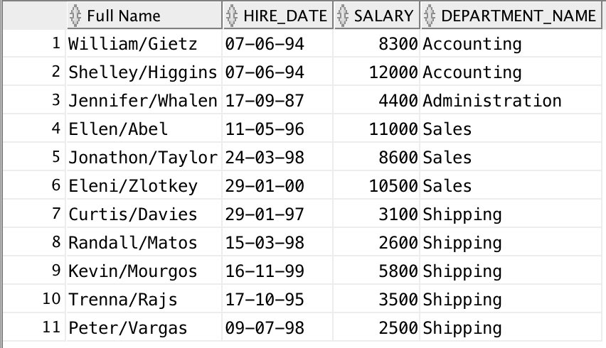

4. Display full name of the manager of each department in provinces Ontario,

California and Washington plus department name, city, postal code and province name. Full name should be in format as follows:

**Last, First.** Use the JOIN and ON form of syntax.

Sort the output by city and then by department name.

**SELECT E.last_name || ', ' || E.first_name AS "Manager’s FullName",**

**D.DEPARTMENT_NAME,**

**L.CITY,**

**L.POSTAL_CODE,**

**L.STATE_PROVINCE**

**FROM EMPLOYEES E**

**LEFT JOIN DEPARTMENTS D**

**ON E.DEPARTMENT_ID = D.DEPARTMENT_ID**

**LEFT JOIN LOCATIONS L**

**ON D.LOCATION_ID = L.LOCATION_ID**

**WHERE L.STATE_PROVINCE IN ('Ontario', 'California', 'Washington')**

**AND (E.JOB_ID LIKE '%MGR%'**

**OR E.JOB_ID LIKE '%MAN%')**

**ORDER BY L.CITY, D.DEPARTMENT_NAME;**

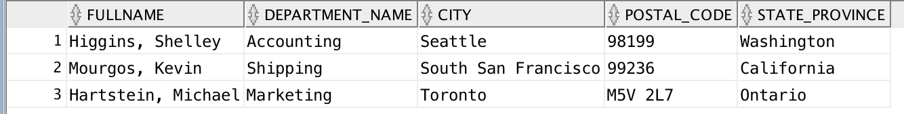

5. Rewrite the previous question by using Standard (Old -- prior to Oracle9i) Join method.

**SELECT last_name || ',' || first_name AS "Full Name" ,**

**department_name,**

**city,**

**postal_code,**

**state_province**

**FROM employees**

**JOIN departments**

**USING (department_id)**

**JOIN locations**

**USING (location_id)**

**WHERE state_province in ('Ontario', 'California' , 'Washington')**

**AND (job_id like '%MGR' or job_id like '%MAN')**

**ORDER BY city, department_name;**

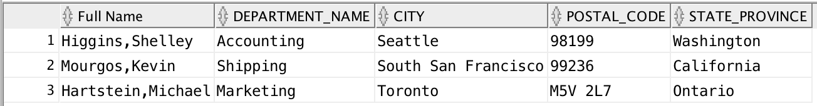

6. Display the department name and Highest, Lowest and Average pay per each department. Name these results *High, Low* and *Avg.*

Use JOIN and ON form of the syntax.

Sort the output so that department with highest average salary are shown first.

**SQL Query:**

**SELECT D.department_name AS "Department",**

**MAX(E.salary) AS "High",**

**MIN(E.salary) AS "Low",**

**ROUND(AVG(E.salary)) AS "Average"**

**FROM departments D**

**LEFT JOIN employees E**

**ON E.department_id = D.department_id**

**GROUP BY D.department_name**

**ORDER BY AVG(e.salary) DESC;**

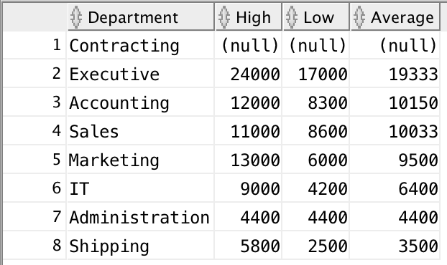

7. Display the employee last name and employee number along with their manager’s last name and manager number. Label the columns Employee,

Emp#, Manager, and Mgr#, respectively. Include also employees who do

NOT have a manager and also employees who do NOT supervise anyone (or

you could say managers without employees to supervise).

**SELECT E.last_name AS "Employee",**

**E.employee_id AS "Employee Number",**

**M.last_name AS "Manager",**

**M.manager_id AS "Manager Number"**

**FROM employees E**

**FULL OUTER JOIN employees M**

**ON e.employee_id = M.manager_id;**

